TECHNICAL PROJECT REPORT

Title of Invention / Project:

**BLUETOOTH EXTENSION BOARD**

Team Members / Inventors:

|  |  |  |  |  |  |  |  |  |
| --- | --- | --- | --- | --- | --- | --- | --- | --- |
| **S.No.** | **Name** | | **Department** | | **Designation** | **Mobile** | **E-Mail** | |
| 1. | | Abhishek Sharma | | ECE | Student | 8894215225 | Abhi174028@gmail.com |
| 2. | | Ritika Kashyap | | ECE | Student | 7347392781 | ritikakashayap@gmail.com |
| 3. | | Ankush | | ECE | Student | 70091418880 | Ankushrj886@gmail.com |
| 4. | | Khushal Thakur | | ECE | Mentor | 9646030764 | khushal.thakur@cumail.in |
| 5. | | Anshul Sharma | | ECE | Mentor | 9478697475 | anshulsharma.ece@cumail.in |
| 6. | | Kiran Jot Singh | | ECE | Mentor | 9463909689 | kiranjotsingh.ece@cumal.in |
| 7. | | Divneet Singh Kapoor | | ECE | Mentor | 9878422653 | divneet.ece@cumail.in |

Section – 1 (IPR Related)

Brief Abstract (500 words):

* Problem our project is solving :

We are solving a problem related to home automation. Home automation typically don’t solve problems by itself but connect different devices and processes the data from each one. Sometimes it becomes difficult to us to control light or other electrical devices in our home it is due to our busy schedule or we want work to be done effortlessly so there is need of smart electricity controller which can make many jobs easier. So our project is related to a remote keen electricity controller or in other words we can say it is wireless smart electricity controller. It helps in controlling the electricity smartly without actual any physical connection with the source or device. It has other benefits also as it saves time and also it has made many jobs easier. Not only this it also an important contribution to the technology and it also improves the electricity or home appliances controlling system.

* How we are solving this problem:

We are solving this problem by constructing a wireless electricity controller. This project will be controlled with an app through a Bluetooth module. With the help of wireless electricity controller basic home appliance home function is realized. The project will help us in many way not it is time saving but will led to many job happen smartly and without any efforts. Our project consists of Bluetooth which helps to give command to module relay which then gives the result as per the command given to the Bluetooth with the help of phone or some other operating devices. The project includes a code which is implemented in the project using Arduino. The most of the program is dependent on the coding and it will run or will output as per the commands or instructions given. So with the help of all of these our problem gets solved.

* Additional modifications that can cater to improved solutions

The project can look more good by properly wiring it and also we can make it light weight so that it can be more portable and will also we can decrease its size so it will take less space. Also we can modify it by using different type of sensors which will help us a lot.

Existing state-of-the-art and Drawbacks in existing state-of-the-art

|  |  |  |
| --- | --- | --- |
| **S. No.** | **Existing state of art** | **Drawbacks in existing state of art** |
| 1 | US20140163751A1 | If we setup this type of automation system in the house then it is not so easy to carry along with us to our journey and it is also very costly |
| 2 | https://youtub.be/TZnrHkjlgLk | We can not carry this type of home automation system along with us anywhere like daily from home to office |

Novel/Additional modifications that you can propose to improve upon drawbacks

* We can try to decrease its weight
* We can add a timer in the app to switch off automatically

Advantages

* It is very portable, and easy to carry anywhere.
* It is durable and cheaper as compare to other market Home automation systems

Block Diagram-:

**ARDUINO**

**BLUETOOTH MODULE**

**MOBILE APP**

**MODULE RELAY**

**EXTENSION BOARD**

**POWER ON/OFF**

Section – 2 (Real Project)

Materials

|  |  |
| --- | --- |
| **Apparatus** | **Cost price** |
| 1.Arduino UNO | 450 |
| 2.5V 4channel module relay | 350 |
| 3.9v adapter | 150 |
| 4.HC-05 Bluetooth module | 300 |
| 5.Jumper wire male to female | 80 |
| 6.Bluetooth control app in mobile | Free of cost |
| 7.Extension board | 200 |
| Total | 1530 |

Circuit Diagram

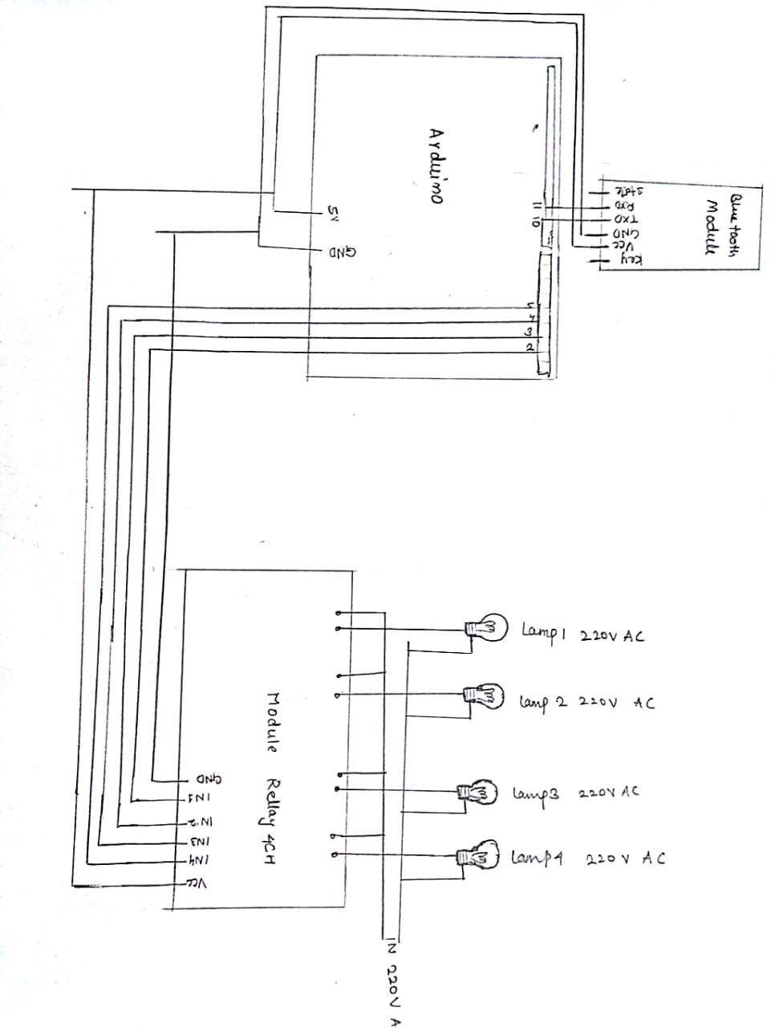

Steps of Circuit Completion

1-Connect Bluetooth module relay with the Arduino uno. (connect RX piin of Bluetooth with the pin no.10 and TX pin with the pin no. 11. Connect VCC with 5V on Arduino and GND with GND on Arduino)

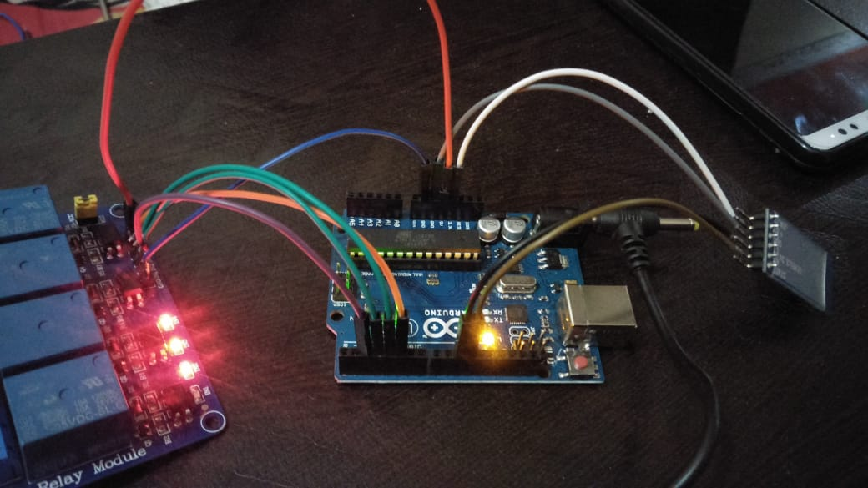

**2- connect** 3v module relay with the extension board. ( Connect normally open connection of module relay 1,2,3,4 with the socket 1,2,3,4 of the extension board. And connect normally closed connections with one wire of AC current and connect 2nd wire of AC current with the 2nd connection of each socket )

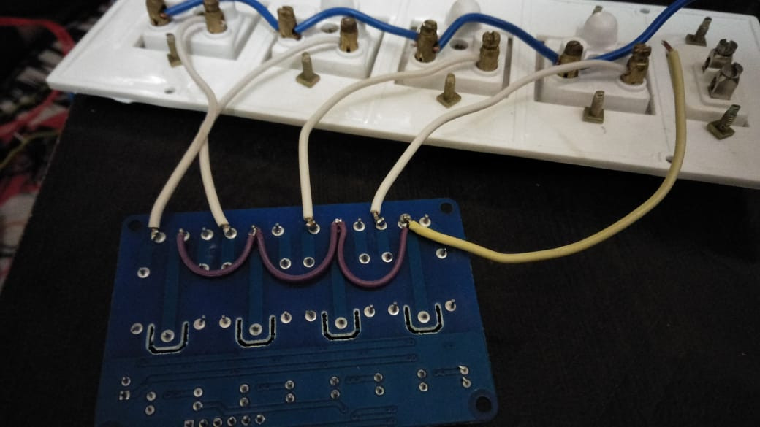

**3-** connect the module relay with the Arduino ( Connect pin IN1, IN2, IN3, IN4 of Arduino with the pin 2,3,4,5 of Arduino and connect VCC with 5V and GND with GND on Arduino)



4- Attach the 9v adapter with the Arduino as a power of source to the Arduino and connect the adapter with AC current source. 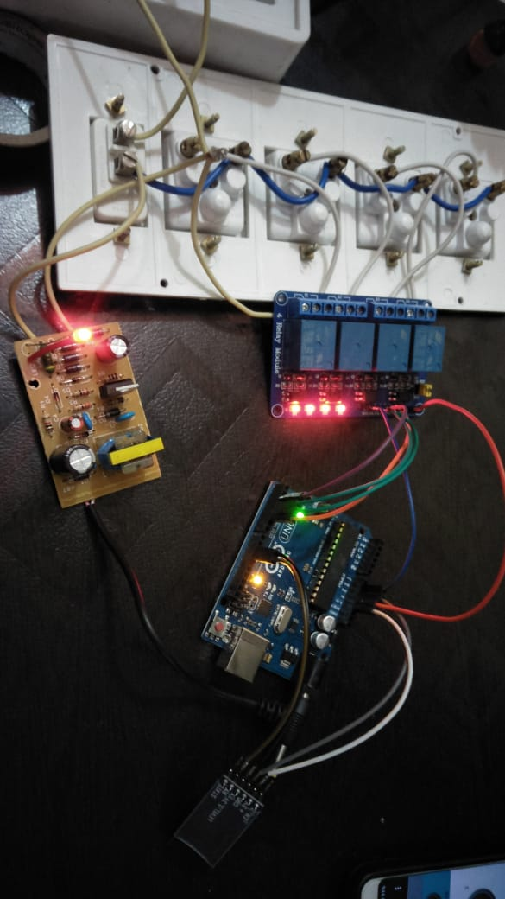

5. After completing all connections fix all the components in the extension board with help of a glue gun

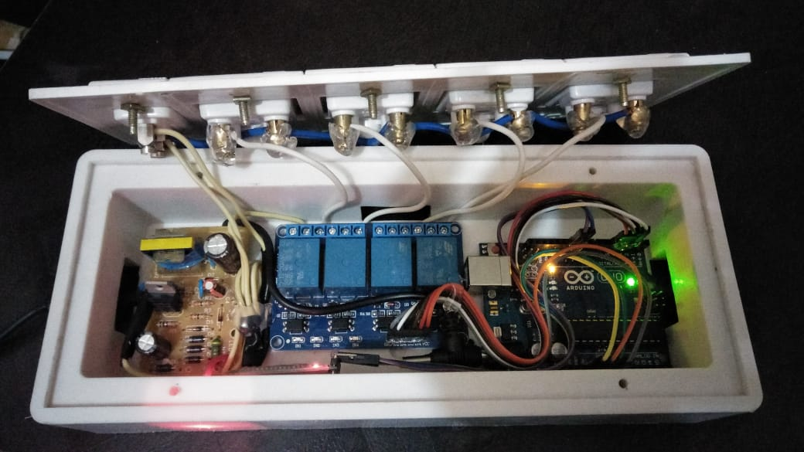

FINAL PROJECT -BLUETOOTH EXTENSION BOARD

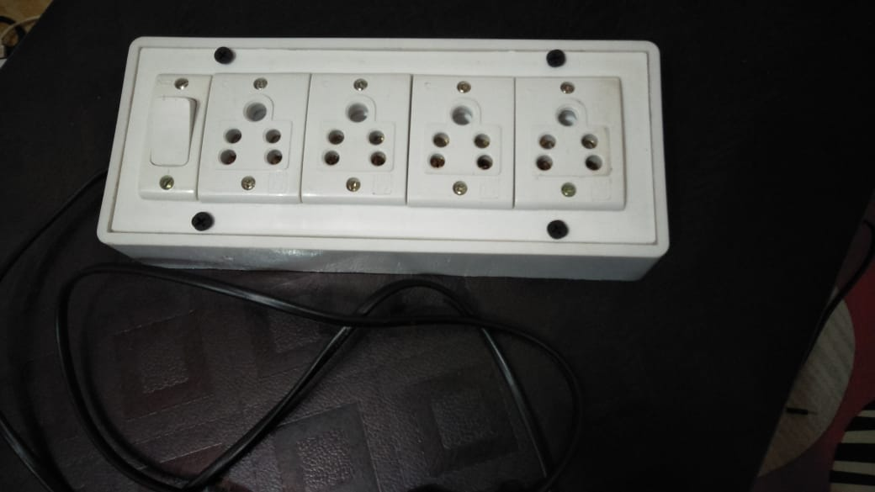

Bluetooth control application for arduino

<https://play.google.com/store/apps/details?id=dev.merahkemarun.arduinobluetoothrelay4chby>

Program code And File data

https://github.com/Abhi174028/Bluetooth-extension-board